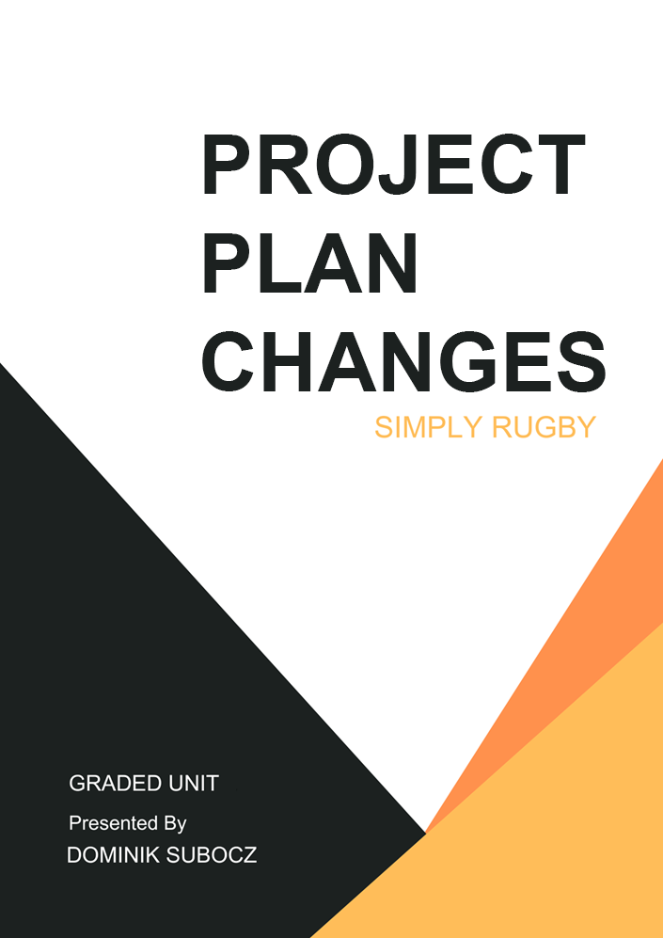

Contents

Changes Made 3

Plan Changes 3

Business Model Changes 3

Business Model Before 3

Business Model After 3

View Model Changes 3

View Model Before 3

View Model After 3

Test Strategy 3

Testing Screenshots 3

# Changes Made

During the development stage, several changes and small adjustments to the project had to be made to improve the project and to make sure it aligns closely with my objectives and meets the requirements of the project.

These changes were based on reviewing how things were going internally, system and functionality overhauls, removing redundant useless stuff from database and website itself and user feedback from testing forms.

## Plan Changes

The most notable changes that I have made during the development stage of the project are changes to the testing plan.

In the plan I have mentioned that I would perform unit and system testing on my web application. I had to abandon both of these testing methods given that, one; I did not have much time left because I have left testing for last week or so, two; I had no idea how to unit test PHP code.

Instead, I have decided to swap these two methods of testing with component and database testing. In the component testing document I was just basically confirming that each component like images, fonts, styles, scripts, html cards load correctly. While database testing was all about testing SQL queries and seeing if the actual result is same or different as the expected result.

## Business Model Changes

During the development stage, I have also made some notable changes to the business models. The only diagram that I believe was left unchanged was the Data Binding diagram, mainly because I believe that it was still conveying still idea even with all the changes made to the web app.

### Business Model Before

This section focuses on showcasing the diagrams designed for the planning stage.

#### Activity

#### Entity Relationship Diagram

#### Site Map

#### Use Case

**Player Management:**

**Event Management:**

### Business Model After

This section focuses on showcasing the updated diagrams made at the end of the development stage.

#### Activity

#### Entity Relationship Diagram

Updates made to the ERD diagram mainly include taking out useless fields or creating new tables/fields.

#### Site Map

The site map of the whole web app has expanded substantially, mainly as a result of new pages being added to the project.

#### Use Case

The diagrams below, also have expanded just like the sitemap previously mentioned. With a live working version of the system, I was able to more clearly replicate each user scenario. I have ran out of time to implement the missing small features, but I will talk about that in the evaluation report.

**Player Management:**

**Junior Player Management:**

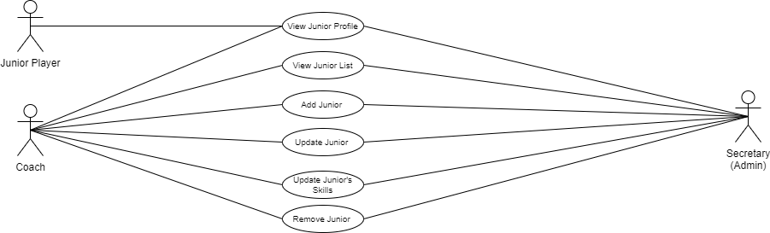

**Non-player Member Management:**

**Event Management:**

**Data & Coach Management:**

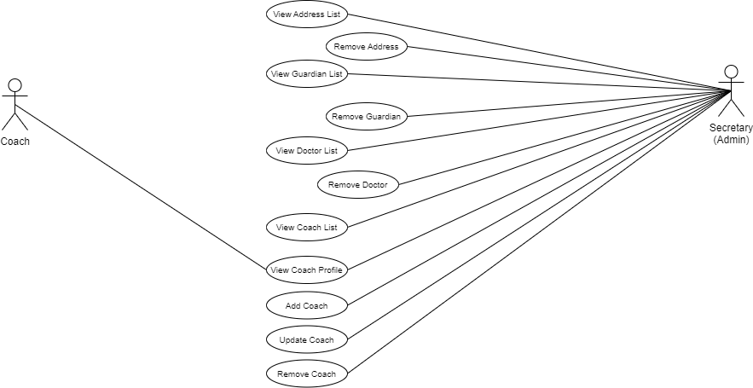

## View Model Changes

### View Model Before

### View Model After

# Test Strategy

# Testing Screenshots